**ASSIGNMENT-2**

**QUES1.)** Implement a banking system using java. Create 3 sub class of Bank : SBI,BOI,ICICI

Classes should have attributes like Name, headofficeAddress, chairmanName, branchCount, fdInterestRate, personalLoanInterestRate, homeLoanInterestRate. All 3 should have following methods:

* add getters and setters for the fields
* print details of every bank (override toString)

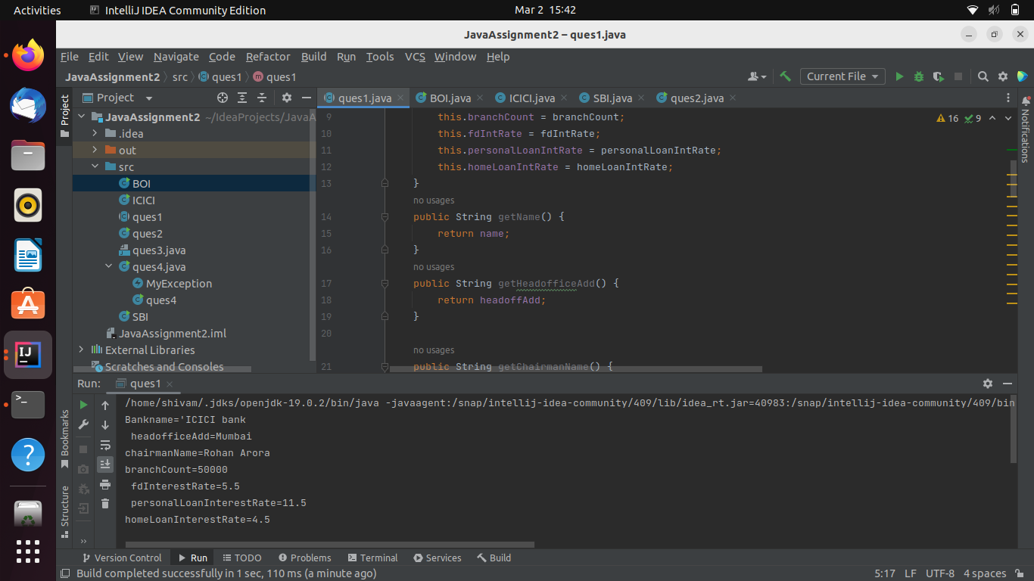

**QUES2.**WAP showing try, multi-catch and finally block.

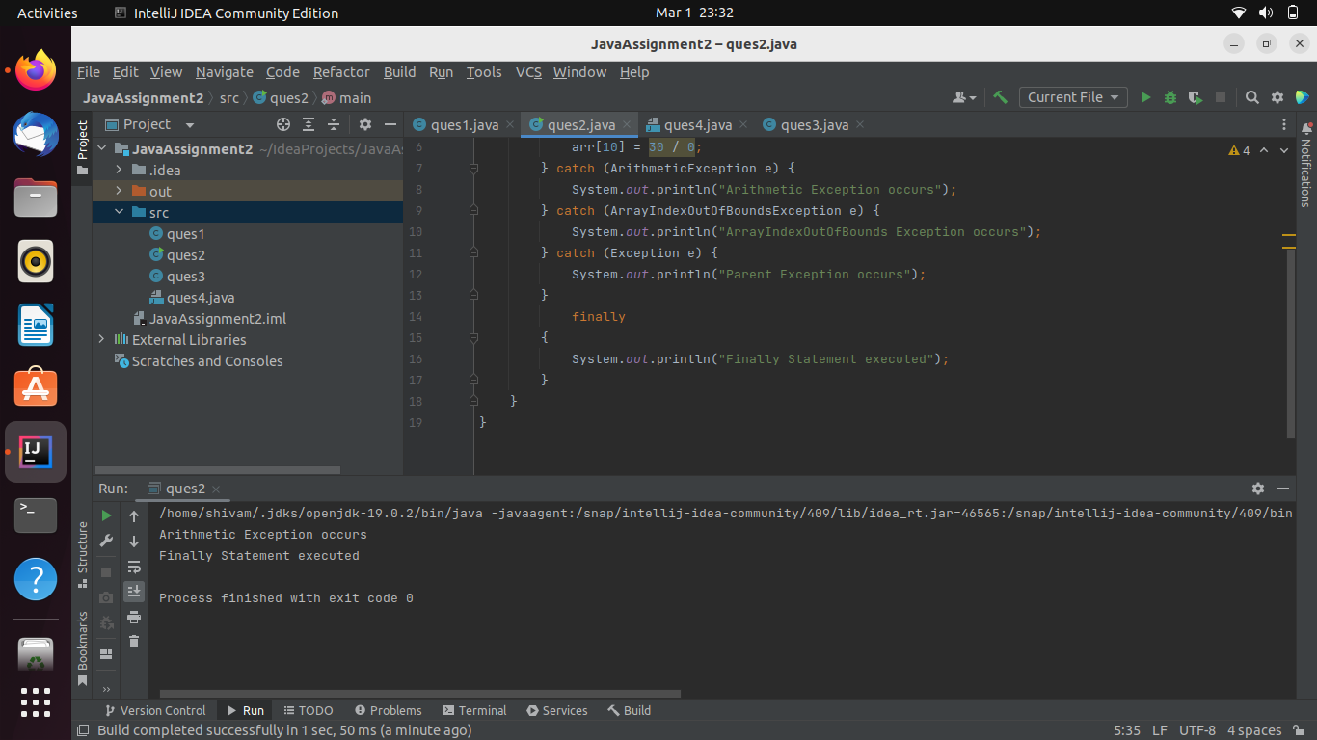

**QUES3.)** WAP to produce NoClassDefFoundError and ClassNotFoundException exception.

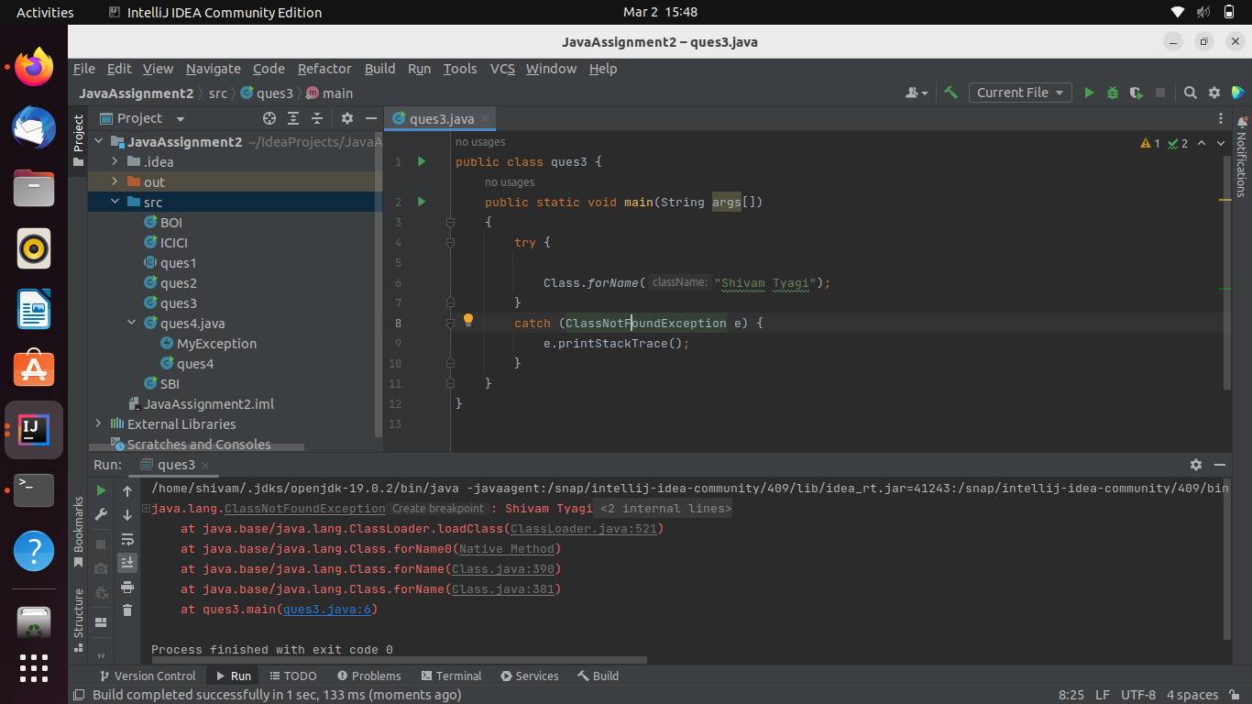

**QUES4.**Create a custom exception that do not have any stack trace.

